Peer Stakeholder Product Validation Reviews (PS-PVRs)
PS-PVRs are designed to mark milestones in maturity of a science product. The review appraises the status of product quality with respect to Program definitions. The panel chair declares products have achieved a maturity level and provides guidance on the path forward to the next maturity level. Before Operations Handover to OSPO, the panel chair is the GOES-R Program Scientist. After Operations Handover to OSPO, the panel chair is the GOES-R Data Operations Manager (matrixed from OSPO). Other members of the panel are from GOES-R Program, OSPO, GORWG (Geostationary Satellite Operational Requirements Working Group), OSGS (Office of Satellite Ground Services), the PRO team, CWG, and AWG.
The Program definitions of the three levels of product maturity (Beta, Provisional, and Full validation) are:
Beta: Data are preliminary and non-operational; undergoing testing and initial calibration and validation. Products are made available to users to gain familiarity with data formats and parameters in accordance with the GOES-R Product User Guide (PUG). Beta products have been minimally validated and may still contain significant errors. They are not optimized for operational use.
Provisional: Data are ready for operations and use in cal/val activities. Performance has been tested and documented over a subset of conditions, locations, and periods. Validation is still ongoing, not all anomalies are known but all known are documented and available to the user community.
Full: Product is operational. All known anomalies are documented and shared with the user community. Performance has been tested and documented over a wide range of conditions. Users are engaged and feedback is assessed.

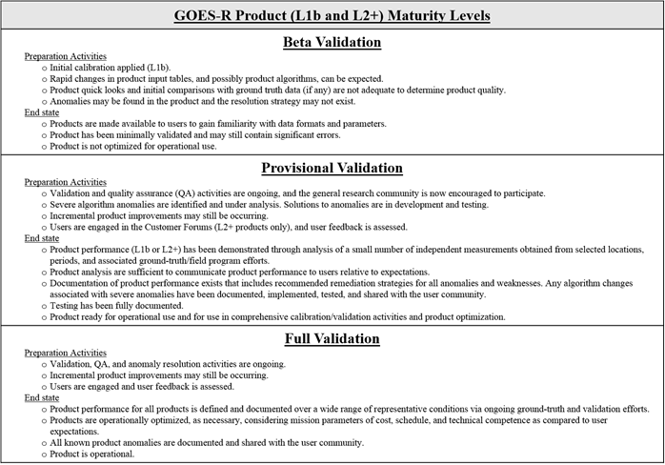

Hyperlinks to individual satellites: GOES-16, GOES-17, etc.

